Protocols
Data Link / 2 Layer
VLAN  Purpose:  separates the network broadcast domains into virtual LANs | Trunk: a port that allows packets of multiple VLANs to pass over it  Access: port on only 1 VLAN | IEEE 802.1Q Tag:  Inserted into the Ethernet frame by the switch  Native VLAN:  frames are untagged frames and switches that receive untagged frames will assume it is for their configured native VLAN  note: the VLAN tag is removed when being forwarded to a Host from a switch |  |  | Inter-VLAN routing:  due to the packet being treated as a frame from a separate LAN, the only way to route VLAN-tagged packets is to send them to an L3 device for routing such as a router or an L3 switch
Address Resolution Protocol (ARP) | Purpose:  resolve IP addresses to a MAC address | ARP Packet Types:  Request, broadcast the query for the MAC addresses  Reply, the device responds with the its IP address |  |  | Every device (host and network nodes) has an ARP cache (not to be confused with MAC address table)
Rapid Spanning Tree Protocol (RSTP)  Purpose: prevents communications loops/broadcast storms by dynamically and virtually disabling ports | Port Roles:  Root (port pointing to root bridge)  Designated (Fully functioning port)  Alternate (blocked port and will replace root if port fails)  Disabled |  |  | Process:  1) Elects Root Bridge with Bridge ID in BPDU  (Priority > MAC address)  2) Elects Root Port for Non-Root Bridges  (lowest root path cost)  3)Elects Designated & Blocked/Alternate ports on Non-Root Bridges  (designated ports have a lower root path cost sent in BPDU than received and blocked ports has a higher cost sent then received)
Port States:
Discarding(doesn’t forward/learn MAC)
Learning(doesn’t forward but learns MAC)
Forwarding (fully functioning state)
First-Hop Redundency Protocol (FHRP)/  Host Standby Router Protocol (HSRP) | Purpose:  provides smooth/transparent fail-over of default gateway by sharing a virtual IP and MAC address between multiple routers | Fail-over Process:  HSRP Standby router will send a Gratuitous ARP (GARP) to claim the VIP and VMAC |  |  | Fail-Over Process:  1) Active Router stops sending periodic Hello Packets  2) standby router assumes active role by sending a gratuitous ARP to the network
EtherChannels / Port-Channel / Channel-Group  Purpose:  aggregate multiple links into a single logical link | Channel Types:  1) Static configuration  2) Port Aggregation Protocol (PagP) – Cisco-Proprietary  3) Link Aggregation Control Protocol (LACP) – IEEE 802.3ad | EtherChannels can be configured on L2 or L3
Network / 3 Layer
General Routing | Longest Prefix Mating Rule:  Routes are chosen based on the longest match after the network address | Route Aggregation / Supernetting:  routes are clumped together based on the lowest bit match of the addresses/routes |  |  | Wildcard mask:  like a subnet mask but inverted to specify the host portion or the portion after the network address
Open Shortest Path First (OSPF)  purpose: dynamically learn and route packets through the LAN and attached LANs | Link-state protocol (all routers must learn the topology and use Dijkstra’s algo to compute path costs) | Phase:  1) Discover adjacent/ neighboring routers  * Enable OSPF (Down State > Init State)  * Router will Multicast an OSPF Type 1 Hello Packet and Exchange Hello Packets with Neighbor (Init state > 2-way State)  (router will send a Hello packet with or without a neighbor field if it has received a hello packet which will be the neighbor router ID)  * Designated Router (DR) & Backup Designated Router (BDR) election; Priority (default is 1) > Router ID, any other router is a DROTHER  2) Learn network topology  (only between any router and the DR & BDR)  * Exchange Database Description (DBD)  (2-way state > Exstart state > Exchange state)  * Exchange LSR,LSU, and LSAck to update missing links in local Link-state database  (Exchange state > Loading state > Full state)  3) Computer path costs to remote subnets)
 | Router ID automatically mirrrors the largest Loopback interface IP address or the highest interface IP address
Load Balancing:  OSPF will use multiple paths if they are of the same cost and to the same subnet  the default max paths is 4 | Areas:  areas split large OSPF networks into small networks so individual routers don’t need to know the whole network  default admin dist: 110
Default interface cost:  any interface of 100 Mbps and higher is 1  recommended that the ref-bandwidth match the largest interface bandwith | OSPF can propagate default routes and limit LSAs by configuring a border interface as a passive interface | Interface Cost config Methods:  1) config ref-bandwidth in Mbps  2) config interface bandwidth in kbps  3) config interface cost diretly  the default cost is calculated as ref-bandwidth / interface bandwidth
Network Address Translation (NAT)  purpose:  translates private IP addresses into Public IP addresses | Private addresses:  10.0.0.0 – 10.255.255.255  172.16.0.0.0 – 172.31.255.255  192.168.0.0 – 192.168.255.255 |  | NAT types:  static – 1-to-1 translation (usually for a server)  dynamic – allocates single addresses from a pool of addresses  Port Address Translation (PAT) – allocates a port number on a single address for multiple addresses / service requests (ports)  NAT/PAT pool overload – dynamic NAT + PAT
Internet Control Message Protocol (ICMP) | 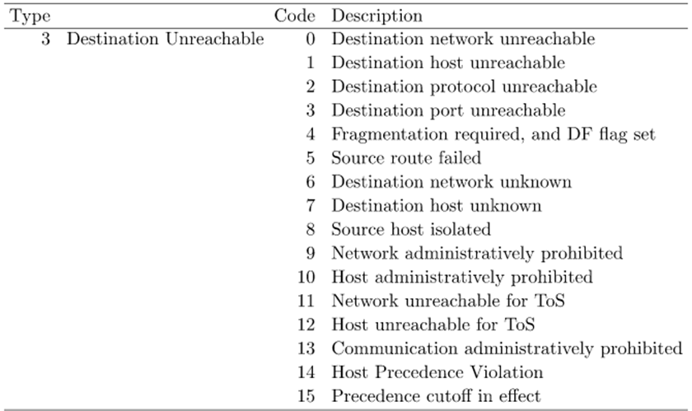
Type Codes:
3 (Destination Unreachable)
11 (Time exceeded)
8 or 0 (Echo Request or reply)
13 or 14 (Timestamp request or reply)
Message Categories:
Query-Reply
Error (the query datagram will be discarded)
Transport / 4 Layer
TCP - Provides reliable data delivery | TCP Sliding Window Flow Control:  * the window is the number of Bytes that can be sent without needing acknowledgment)  * as bytes are sent the window shrinks from the trailing edge and transmission stops at 0  * the window size expands when an ACK is received by W bytes which is in the received ACK segment (the receiver follows the same process but will send W as their remaining window size if not ready and remaining + expanded size if ready)  both sender and receiver have 2 buffers/windows to send-receive data simultaneously; they piggy-back ACK segments on data segments to save transmission bandwidth |  |  |  | TCP Connection Closing:  1) client sends a FIN to the server  2) server replies with a FIN + ACK  3) client ends with ACK
Services:  Addressing – identify application processes  Connection management – client and server establish a connection before data transmission and closes connection  Flow control – prevents sender from transmitting too fast  Error control – retransmits segments if needed  Congestion control | TCP Error Control:  * adds Retransmission Timeout (RTO) to Sliding Window Flow Control to correct for possible errors such as (Lost Data/ACK, Damaged Segment, Duplicate Segment, or Out-of-order Segment) |  |  |  | TCP connection establishment:  1) client sends a SYN to server  (initial sequence number/ISNc)  2) server replies with a SYN-ACK (ISNs)  3) client completes the process with an ACK (acknowledgment number field is ISNs + 1)
UDP- Fast delivery of data with no reliability/error checking |  | provides unreliable connectionless datagram-oriented service
Application / 7 Layer
DHCP
DNS

OSPF Packet Types

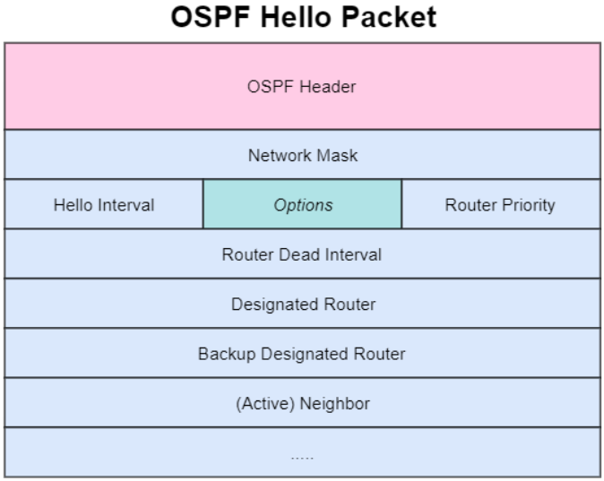
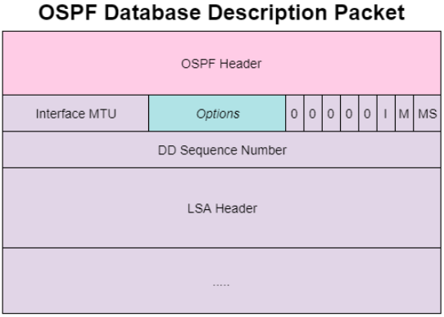
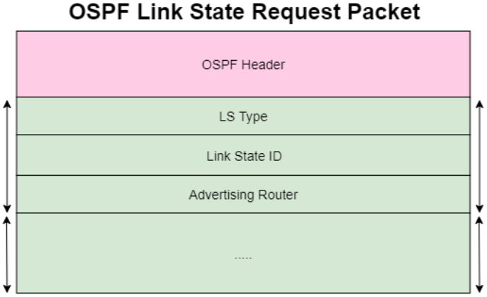
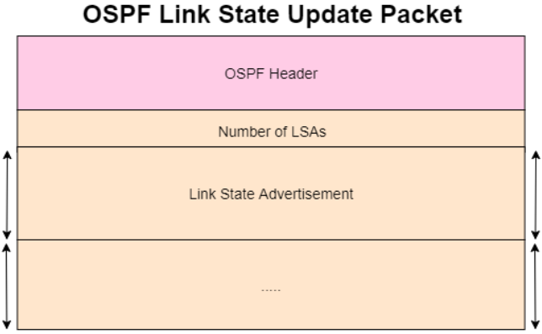
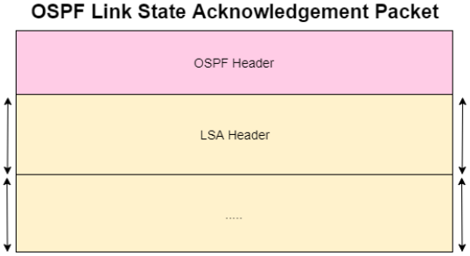
Configuration Commands
Configuration Commands

